|  |
| --- |
|  |
| Identifying & Evaluating Technology Innovation |
| The 4 Cs approach |
|  |
| **Manish Chandra K N** |
| **12/8/2014** |

|  |
| --- |
|  |

# Abstract

It is evident from news of the industry that ‘innovation’ is the buzzword, not just in the technology industry but in all business in the recent times. However, this widely-heard term is also the one term widely misinterpreted by the rank and file and sometimes intimidates even the investors and shareholders. This paper seeks to present the findings of an ongoing study aimed at providing a structured methodology to identify, evaluate and promote potential innovation candidates. More specifically, this paper is intended to provide a structured and lucid approach to identifying and evaluating the innovation trends in the technology business

*Keywords: Innovation, Strategy, Hi-Tech, Trends Framework*

Contents

Abstract 1

Introduction 3

Scope 3

Innovation 4

Identifying the Themes of Innovation 4

Connectedness 4

Convenience 4

Customization 5

Community 5

Evaluating Innovations – A methodology 5

The Innovation Gates & Criteria 6

I. Early stage Criteria for Choosing Areas of Innovation 6

II. Ongoing Evaluation of Technology Innovation Success 7

III. Later Stage Evaluation of New Product/Service Success 7

Conclusion 7

Exhibit 8

References 8

About the Author 8

# Introduction

It is evident from news of the industry that ‘innovation’ is the buzzword, not just in the technology industry but in all business in the recent times. However, this widely-heard term is also the one term widely misinterpreted by the rank and file and sometimes intimidates even the investors and shareholders. This paper is intended to provide a structured and lucid approach to identifying and evaluating the innovation trends in the technology business.

While large business houses and conglomerates see innovation as the means to keep their businesses growing at an ever-increasing rate, many ‘innovative’ start-ups or spin-offs took their respective industries by a storm and went on to become market leaders. However, most companies see innovation as a means of differentiating themselves from the competition and the likes of Google and Apple consciously strive to make it a core competency.

Examples abound of the organizations that set out down the innovation road only to find the initiatives end in failures, with a lot more than market share and market capitalization lost (case in point- Infosys). In addition, there are a very many organizations in the technology industry that have missed the innovation bandwagon and now face (or already faced) inevitable extinction (cases-Blackberry, Nokia, Kodak etc.). However, pursuing innovation is not a surefire way of staying or growing in business- the average success rate of traditional innovation processes is just 17%. This should not be surprising given most big-ticket launches vanish from the market in just a few years (Microsoft Zune & Sony in portable music players)

The Intended Audience

* Managers and Technologists
* Investors- PE/VC firms, shareholders
* Entrepreneurs
* Innovation champions

In this context, this paper seeks to present the findings of an ongoing study aimed at providing a structured methodology to identify, track and promote potential innovation candidates. More specifically, it is focused on the trends of technology innovation in the recent past and the general direction in the years to come.

# Scope

A majority of the analysis is based on data from the technology industry and almost all the examples cited are specifically from the Hi-Tech industry- comprising Information and Communication Technology, Electronics, Semiconductors, Computers and the Internet businesses. However with technology being incorporated in most other aspects of human lives by means of automation and recently the Internet of Things, it has been noticed that the findings of the study can be adapted to most other businesses of the current times.

# Innovation

Innovation is the process by which an idea or invention can be translated into a marketable good or service. It is the process of creating an improved product or service from an invention, where an ‘invention’ is the act of creating or developing a new product or process or business model. Innovation therefore refers to the use of a better and novel idea or method, whereas invention refers more directly to the creation of the idea or method itself.

Based on the change impact and market scope, innovations can be broadly grouped into two categories[1]: Sustaining innovations and Disruptive innovations. Sustaining innovations seek to aid the incumbent companies to improve on established sets of products/services thereby serving their customers better. These innovations may either be incremental or discontinuous/radical. On the other hand, disruptive innovations provide an altogether different value proposition aimed at customers different from the current clientele, thereby effectively creating new markets for the firm.

# Identifying the Themes of Innovation

Our past research involved identifying trends in technology innovation. We assessed the internal environment, the external environment and the innovation process within the organization; we call it the ‘Innovation Trends Framework’. From that research, we observed how different participants influenced the evolution of a technology in the various stages of its life cycle and how a successful technology could be leveraged to create the next generation of successful products/services or could be doomed to oblivion- depending on the innovation environment.

We identified themes that were common to technology evolution in ‘the information age’- **Connectedness-Convenience-Customization-Community (The 4Cs).** Each of these themes will be discussed in the following sections.

### **Connectedness**

*Does the innovation enhance connectedness of the users?*

This represents any innovation that enhances the connectedness of the users, improving the accuracy, precision, speed and frequency of delivering data and information to the users. Mobile Technologies over the four generations, rising internet speeds, online maps, geo-tagging are few of the glowing proponents of this theme.

### **Convenience**

*Does the potential innovation provide greater convenience to the users?*

This represents improving the timeliness and relevance of the information delivered to the customers by means of reducing complexity in using the product/service, addressing usage constraints and improving users’ convenience. This theme underlies Cloud technologies- storage, computing, business models such as the pay-per-use model, e-commerce, Near Field Communication (NFC), gesture & voice controls.

*Fig ii. The 4 C’s framework*

### **Customization**

*Does the innovation provide a high(er) degree of customization ability to customers?*

This represents transitioning from a generic, one-size-fits-all approach to delivering product/service offerings personalized at the individual level. A popular implementation of this theme is in context sensitive applications providing relevant information as and when needed by the users. Silently working in the background are analytics & Big Data, digital marketing tools, Content Management Systems (CMS) etc. which make this a relevant current theme of innovation.

### **Community**

*Does the innovation aid in building a community of users (on the demand side) or a supplier ecosystem (on the supply side)?*

This represents an ability to build a community or ecosystem around the innovation, thereby leveraging Network effects. The community may comprise of not only users but also suppliers thereby ensuring increased supplier/user tie-in and retention. The increased switching costs and entry/exit barriers also seek to provide the organization a sustained long term competitive advantage. Mobile operating system platforms such as Apple iOS, iTunes, Google Play, facebook, Whatsapp all have been successful building a community around the products and services.

# Evaluating Innovations – A methodology

A stage gate process is preferred in identifying and evaluating potential areas for innovation. A broad area progresses through the stages and is refined successively until one/few specific technology areas emerge as potential candidates for investment of the organization’s resources. Between the successive stages, there are gates- of performance criteria - which the technologies should pass through to qualify as suitable contenders for the next stage. Understandably, the criteria comprises of metrics that are most important to each specific organization.

However, it has been observed that through most of the stages (and the corresponding ‘gates’), the metrics and performance criteria are identical for a majority of successful innovating organizations. A typical stage-gate process for evaluating innovations is presented in Fig. i. The go/no-go evaluation criteria at the gates are discussed in some detail in the following section.

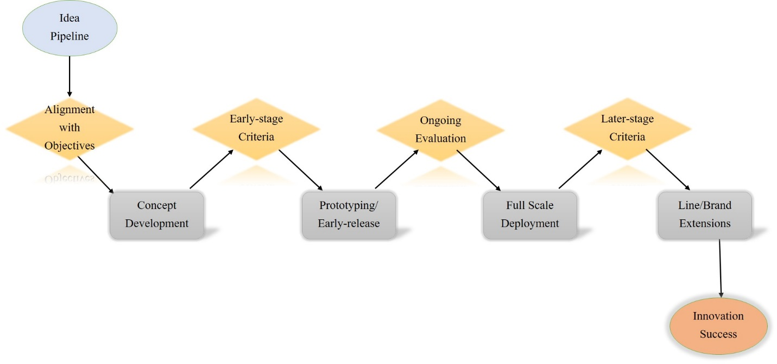

*Fig. i: A Typical Innovation Stage-Gate process*

## **The Innovation Gates**

At any given point, there may be several novel areas that would be competing for the limited available innovation resources. It is critical that these areas are assessed and evaluated and those that align to the organizational goals are chosen.

1. Early stage Criteria for Choosing Areas of Innovation

Lead User analysis presents with customer insights that could be used to identify areas to innovate in. Traditional financial metrics are unsuitable during the early stages of Innovation as the innovations are inherently novel and do not have historical data. Nevertheless, ideas in this stage can be assessed for qualitative criteria that provide a strategic business advantage in the long run. Early stage innovations are evaluated for factors such as potential first mover advantages gained by the organization, market readiness and maturity of the technology, competitive structure in supporting industries and benefits gained in better compliance to regulatory policies and industry standards.

1. Ongoing Evaluation of Technology Innovation Success

Technology Innovation is not a one-shot panacea. Innovation projects need careful and continual monitoring and mentorship. We often observe innovation projects being shelved due to lack of sponsorship, more so in cross-business innovations and in large organizations. On the other hand, not all innovation projects deserve the scarce organizational resources. Some factors that must be evaluated continually in order to track the evolution of the technology and the stage in the innovation lifecycle[2] are:

* *Scale & Scope*

Extent of utilization of the technology, in terms of the number and type of diverse areas the technology is being used in

* *Temporal characteristics*

Rate of adoption and diffusion of the technology over time, in multiple industries

* *Controls*

Extent of controls on funding, market access, standard setting, regulation and taxation, tariffs and quotas on the technology and its component products/services

1. Later Stage Evaluation of New Product/Service Success

Once a product/service passes through prototyping and is deployed, there will be enough test data available for quantitative evaluation. Metrics such as revenue acquired from new product/service lines, royalty from licensing associated Intellectual Property, market share captured etc. are popularly used metrics in this stage. Also, strategic qualitative metrics such as future revenue streams created, competitive advantages and competencies acquired, alliances and partnerships created are useful metrics to evaluate success.

# Conclusion

With so many diverse categories of innovations, each with its own idiosyncrasies, it is indeed very difficult to identify the next big innovation. Lead user analysis, coupled with the 4Cs approach is a powerful tool to identify areas of innovation. Once identified, the evaluating methodology and criteria proposed here aid in choosing and keeping innovation ideas and projects that will have a significant business impact.

# Exhibit

Identifying the underlying themes of technology innovation

|  |  |  |  |  |
| --- | --- | --- | --- | --- |
| **Theme** | **Convenience** | **Connectedness** | **Customization** | **Community** |
| Mobile devices |  |  |  |  |
| Data Analytics |  |  |  |  |
| Social Media |  |  |  |  |
| Cloud technologies |  |  |  |  |
| Big Data |  |  |  |  |
| Mobile applications |  |  |  |  |
| Gamification |  |  |  |  |
| Artificial Intelligence |  |  |  |  |
| IoT, beacons |  |  |  |  |

Any area or technology which addresses one or more of these 4 Cs has historically led to profitable innovation and is expected to have a potential for profitable innovation in the areas of technology, in the near future.

# References

Christensen, Clayton C. (1997). *The Innovator’s Dilemma: When New Technologies Cause Great Firms to Fail;* Harvard Business School Press

Liebenau, J. (2007). *Innovation Trends: Prioritising Emerging Technologies shaping the UK to 2017.* London: Department of Trade and Innovation (DTI)

# About the Author

Manish Chandra K N is an Innovation Evangelist with Tata Consultancy Services, focusing on Technology Solutions. He specializes in the areas of Strategy, Innovation and New Business Development in the Hi-Tech industry. He has a Post Graduate Diploma in Management from the Indian Institute of Management- Kozhikode, and is an Electronics and Communications Engineer by qualification. He can be reached at manishchandra.k@tcs.com

1. Christensen, Clayton C. (1997). *The Innovator’s Dilemma: When New Technologies Cause Great Firms to Fail;* Harvard Business School Press
2. Liebenau, J. (2007). *Innovation Trends: Prioritising Emerging Technologies shaping the UK to 2017.* London: Department of Trade and Innovation (DTI)